What happen when if we use make up or do some changes to image-

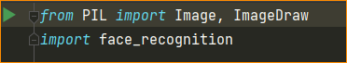

Load the image

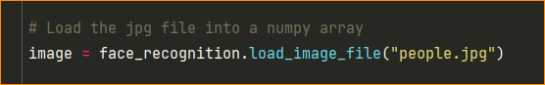

Recognize the face land-marks

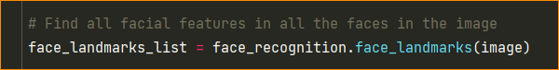

Convert fill format



Drawing the face land marks. Making a image draw object

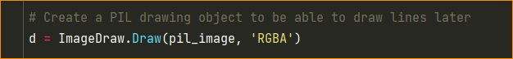

Draw line Eye brows, draw line purple (128,0,128) and transparency = 100 line width 3px

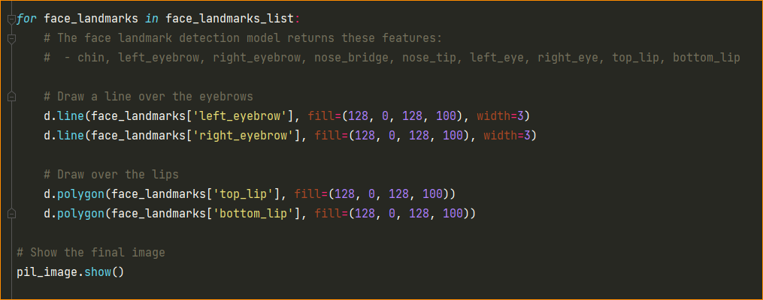

After the result is- add makeup and eye blows



Now recognize the face –

Same – import libraries and set the known image (Drew image)

